SLIDE | ACTION | CONTENT FOR CHAT BOX OR POLL
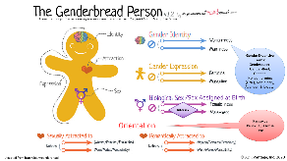 | Chat Box Info | Glossary of Terms Resources:  https://www.hrc.org/resources/glossary-of-terms  https://www.shrm.org/resourcesandtools/legal-and-compliance/employment-law/pages/glossary-on-gender-identity-and-sexual-orientation.aspx  Understanding more about Transgender Individuals:  https://transequality.org/about-transgender
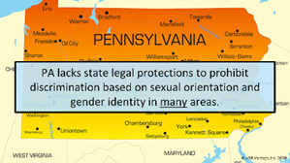 | Chat Box Info | Link to State Laws:  https://www.hrc.org/resources/state-equality-index
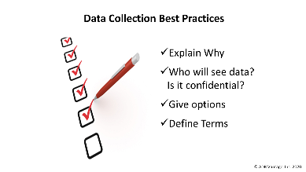 | Chat Box Info | The Center for Diversity & Inclusion at American University suggests spending some time in introspection before asking about gender in a survey. The Human Rights Campaign echoes this sentiment, particularly when it comes to employers collecting demographic data about employees.  - Determine why you’re asking about gender in the first place. If it’s not a crucial part of your data analysis plan, you may be able to eliminate the question altogether.  - If you do decide to ask about gender, craft the question carefully. Be sure you don’t conflate biological sex and gender and create a question that allows respondents to answer honestly and comfortably.  - If you must ask about gender, considering adding an explanation that offers how the info will be used and who will see it. Often organizations will list a statement such as this: “We are required to collect demographic data for our federal partners. We recognize and appreciate that these gender categories may not match your gender identity. If possible, please indicate to which gender you identify the most or leave the option blank.”
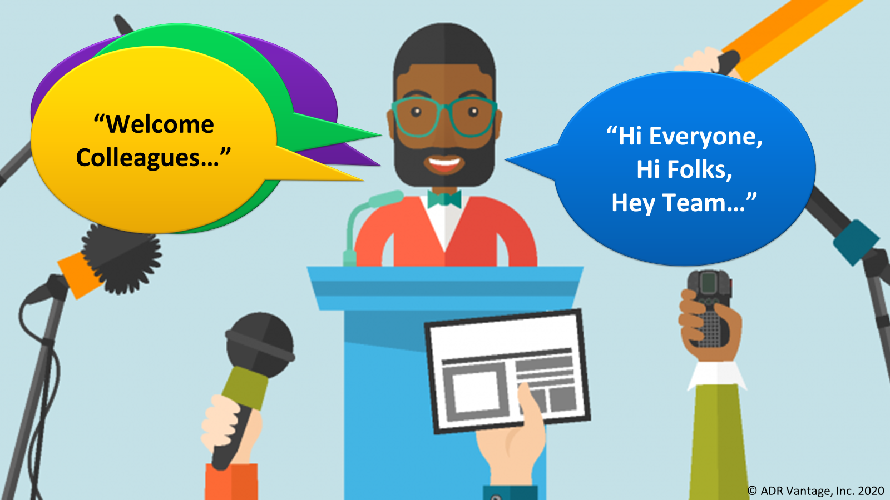 | Chat Box Info | Gender Inclusion Terminology Around the World  https://www.washingtonpost.com/world/2019/12/15/guide-how-gender-neutral-language-is-developing-around-world/
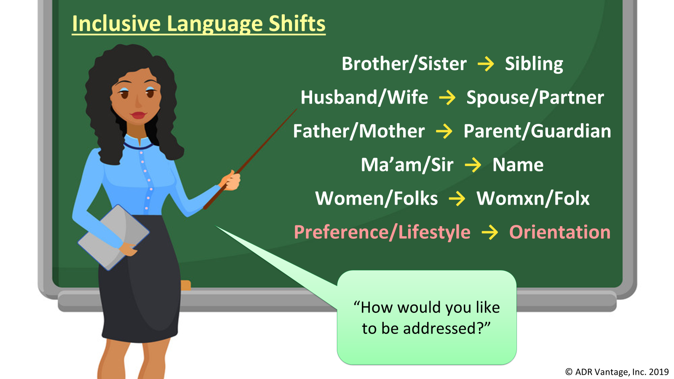 | Chat Box Info | We can be more inclusive in everyday conversations by using gender-neutral or gender-inclusive terms. Some examples include:  - Folks, folx, or everybody instead of guys or ladies/gentleman  - Humankind instead of mankind  - People instead of man/men  - Members of Congress instead of Congressmen  - Councilperson instead of councilman/councilwoman  - Chairperson or Chair instead of Chairman  - First-year student instead of freshman  - Machine-made, synthetic, or artificial instead of man-made  - Businessperson or Representative instead of Businessman  - Staffing an event rather than manning an event  - Parent/Caregiver/Your Adult or Grown-up instead of mother/father  - Child instead of son/daughter  - Kiddo instead of boy/girl  - Sibling instead of sister/brother  - Family Name instead of Maiden Name  - Nibling instead of niece/nephew  - Partner, significant other, or spouse instead of girlfriend/boyfriend or wife/husband  - Flight attendant instead of steward/stewardess  - Salesperson or Sales representative instead of salesman/saleswoman  - Server instead of waiter/waitress  - Firefighter instead of fireman, Police Officer instead of Policeman  - Owner instead of Landlord  - Postperson, Mailperson or Mail Carrier instead of postman/mailman  - Workforce instead of Manpower

