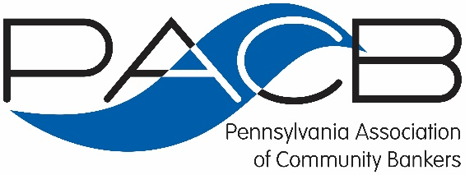

Education Committee Purpose

Members of the Education Committee are asked to serve as a strategy group that discusses trends in community banking and adult education. Through discussion and engagement, the PACB looks to garner insight for development of future curriculum, better understand how to effectively market the Association’s education value proposition and uncover new ways to effectively address the training and educational needs of our membership and community bankers at large.

Committee Members are also requested to serve as educational liaisons with their bank and other training colleagues. Committee members are also encouraged to consider other organizations that might bring value to PACB’s educational offerings through strategic partnerships.

