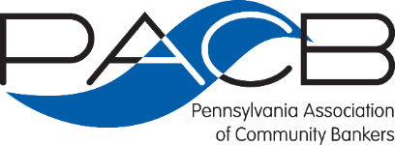

2021 Maximizing Mutuality Conference
June 2-3 | The Hotel Hershey | Hershey, PA

PREMIERE EVENT SPONSOR:

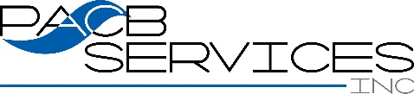

AGENDA
Day I - June 2

8:30 a.m. REGISTRATION/CONTINENTAL BREAKFAST
Garden Terrace Lounge

8:45 a.m. PACB WELCOME/OPENING REMARKS
Garden Terrace Ballroom
Lori Cestra ▪ Chair ▪ PA Association of Community Bankers

9:00 a.m. Thinking Strategically: Strengths and Threats to the Mutual Model”
Jim Clarke, PhD.
Clarke Consulting
Villanova, PA

During this session Dr. Clarke will discuss:
- Understanding our mutual bank’s business model.
- Assessing your opportunities in the current environment.
- Assessing the threats to mutual banks
- The Board’s role in the planning process: be bold, but realistic.

Bio: Dr. James Clarke is the Principal of Clarke Consulting, a Villanova, Pennsylvania firm specializing in ALCO issues and strategic planning for community banks. Jim has lectured on asset/liability management at the Stonier National School of Banking sponsored by ABA, the Southwest Graduate School of Banking, the New England School of Banking and Connecticut School of Banking. He conducts ALM seminars for many state associations, and for Risk Management Association (RMA) and Financial Managers Society (FMS). Jim also conducts board education programs on ALM for a number of state associations. In 2018 through 2020, Jim spoke at the Connecticut, and Pennsylvania Association of Community Bankers conventions and number of director conferences. Dr. Clarke is on the Board of a community bank, and is a Director of an investment company. Jim is also on the Editorial Board of the RMA.
10:15 a.m. REFRESHMENT BREAK & NETWORKING
Garden Terrace Lounge

10:30 a.m. Squared Away-How Can Mutuals Succeed as Economic First Responders
Jeff Marsico
President
The Kafafian Group
Bethlehem, PA

The no “shareholder” bromide shouldn’t equate to tiny profits. The operating discipline enforced by shareholders creates a larger pool of resources for all other constituents too. How do you replace that cultural imperative to be more disciplined so you are more meaningful to employees, customers and community?

Key points to be covered: People First ▪ No amount of execution can replace bad strategy ▪ Who cares about products and marketing ▪ Creating A Valuable Institution

Bio: Jeff has been with The Kafafian Group since its inception and is a founding shareholder. He oversees and works in all lines of business and areas of expertise, with a focus on strategy, profitability, and financial advisory.

He began his banking career in 1985 and his experience includes: financial institution mergers and acquisitions, consulting and capital formation with Tucker Anthony Sutro Capital Markets (now RBC Capital Markets); retail branch management and merger integration with First Maryland Bancorp (now M&T Bank Corporation); IT and trust operations with Northeastern Bank of Pennsylvania (now PNC Financial Services Group, Inc.).

He serves on the faculty of the ABA School of Bank Marketing and various state associations’ executive development programs. He is a frequent speaker and commentator at industry events, and is a recognized community financial institution blogger.

11:30 DEI Conversations in the Boardroom
Tara B. Taylor, MPA (she/her/hers)
Managing Director
ADR Advantage
Washington, DC

Bio: Tara Taylor brings almost 20 years of experience directing and creating programs with the Maryland Commission on Civil Rights in workplace conflict resolution, organizational development, leadership development and, most recently, has become a leading expert in the growing field of Diversity, Equity and Inclusion.

12:30 noon LUNCHEON Sponsored by:
The Circular Dining Room
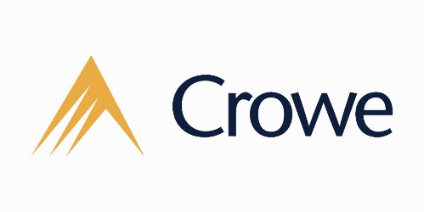

1:30 p.m. Compensation and Benefits Arrangements Common to Mutual Institutions
Thomas P. Hutton, Partner
Luse Gorman, PC
Washington, DC

This session will focus on compensation and benefits matters important to community banks and, in particular, mutual institutions. It will cover the issues community banks face as the country comes out of the COVID-19 pandemic and how mutual institutions can use certain compensation and benefits arrangements to attract and retain valuable employees and executive management. It will also cover how compensation and benefits arrangements are handled when mutual institutions decide to merge.

Bio: Tom Hutton is a partner in the firm’s Executive Compensation, Employee Benefits and Taxation Group. Mr. Hutton has been practicing in the executive compensation and employee benefits area for 20 years. He has extensive experience in designing and drafting tax-qualified and non-qualified arrangements, and advising public and private employers on tax issues, including Code Sections 409A, 280G, 368(a) and 162(m). He routinely counsels clients on employment and change-in-control agreements, executive severance arrangements, SEC executive compensation disclosure, corporate governance and succession planning. He also regularly works on clients with respect to bank-owned life insurance arrangements and split-dollar life insurance agreements. He actively counsels clients on employee benefits and tax issues in mergers and acquisitions.

Prior to entering private practice, Mr. Hutton served as an Attorney-Advisor at the United States Tax Court.

2:30 p.m. Corporate Governance Issues Facing Mutual Institutions
Daniel P Weitzel, Of Counsel
Of Counsel, Locke Lord LLP
Washington, DC
The session will focus on the governance issues facing Pennsylvania mutual savings banks and Pennsylvania domiciled federal mutual savings banks and associations. The landscape has been changing and is continuing to change. Legislative initiatives and regulatory oversight are taking a more activist posture when it comes to what is considered appropriate governance of mutual banks. This applies to board, executive and bank wide considerations. In addition to what would traditionally be considered corporate governance matters, there are emerging trends, not the least of which are DEI, social and environmental. Every PACB member needs to be mindful and actively managing governance requirements and expectations.

Bio: Daniel P. Weitzel represents banks before the federal bank regulatory agencies as well as the many state banking departments. This representation is regarding both transactional and regulatory compliance matters. Daniel also represents clients in corporate and securities law, focusing on mergers and acquisitions and other corporate reorganizations, private placements of both debt and equity and general corporate business planning and counseling. Daniel has represented companies and individuals in numerous instances relating to corporate control issues and financial transactions. Furthermore, Daniel has also represented investment banks and other entities in acquisition, divestiture and capital raising transactions.

3:30 p.m. PACB Legislative Update
Kevin Shivers, President & CEO
Jordan Grant, Director Government Relations

4:00 p.m. ADJOURNMENT

6:00 p.m. NETWORKING RECEPTION
The Castilian Room
Sponsored by:

7:00-9:00 p.m. DINNER – The Castilian Room
Sponsored in Part by:

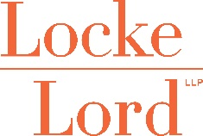

MAXIMIZING MUTUALITY CONFERENCE
Day II- June 3 ▪ The Hotel Hershey

Premiere Event Sponsor:

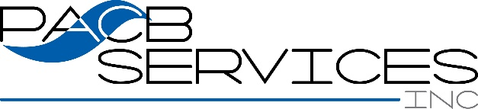

8:15 a.m. BREAKFAST BUFFET -Garden Terrace Lounge
Sponsored by:

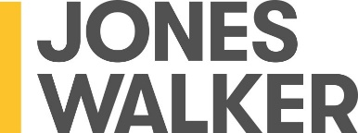

8:45 a.m. The Loyalty Factor: Translating Relationships Into Non-Interest Income
Dr. Sean Payant
Senior EVP, Chief Strategy Officer
Haberfeld
Lincoln, NE

EDUCATION SPONSOR:
As an industry, our data shows we have an average life cycle with consumers and businesses of almost 10 years. Given this loyalty factor, what needs to happen to attract significantly more retail and business opportunities, while deepening the relationships we have with each of them? During this session, we will offer proven strategies to grow your financial institutions personal and business checking core customer, enhance overall non-interest income and create additional engagement by providing more product and service solutions to more people.

Key Points to be Covered:
• Understand methods to significantly increase core customer acquisition • Identify specific strategies to enhance non-interest income • Explore opportunities to create additional engagement with new and current customers

Bio: Sean Payant, Chief Strategy Officer, served as the Executive Director of the Schools of Banking for nine years prior to joining Haberfeld. He has administered, instructed, and authored materials for 17 different banking schools attended by bankers from 18 states. He has published articles on financial institution marketing, employee engagement, goal setting and community financial institution differentiation. Sean has presented more than 100 keynote and breakout sessions at industry meetings. He holds Masters and Doctor of Philosophy degrees from the University of Nebraska.

9:45 a.m. Trends of High-Performers – Strategies, Models &Technologies
Thomas W. Grottke, CPA
Crowe LLP | Managing Director
Growth & Intelligence Consulting – Banking
Hartford, Connecticut

Crowe has been tracking High-Performing Banks, both stock and mutual ownership, for years and we have correlated those business strategies, operating models, technologies, and other relevant practices with those banks that are in the upper quartile of earnings performance of their industry segment and size. Our research has culminated in a over a decade of direct bank consulting experiences coupled with a six-year analytical study of bank industry performance. We share our observations, our findings, and provide supporting facts for our assertions of what strategies, business models, and technologies are driving consistently high-performance.

Bio: Tom Grottke is a managing director in the consulting group at Crowe. He leads performance improvement consulting services for financial institutions. Tom has more than 34 years of professional experience as an auditor or consultant working with management teams of financial institutions of all sizes to drive strategy into action. Tom specializes in providing strategic advisory services and enterprise and line-of-business change programs through technology and/or operational consulting services.

Tom is a regular speaker on banking trends at industry association seminars and events with the Connecticut, New Jersey, Massachusetts, Illinois, and Pennsylvania banking associations, at technology provider annual meetings, and at universities.

10:45 a.m. Recent Developments Regarding Mutual Bank Mergers as a Strategic Opportunity.
Richard Fisch, Partner
Jones Walker LLP
Washington, DC

Bio: Richard Fisch is a Senior Partner in the Washington, DC office of Jones Walker LLP. He is active in the firm’s Bank Regulatory, Corporate, Mergers and Acquisitions, and Executive Compensation practices. He has been involved with numerous merger and acquisition transactions involving mutual institutions and stock institutions. He represents financial institutions in the areas of mergers and acquisitions, branch sales and purchases, charter conversion transactions, mutual to stock conversions and mutual holding company formations, executive compensation and benefits matters, corporate governance, conversions of credit unions to mutual savings institutions, and other regulatory and corporate matters for financial institutions. Mr. Fisch received his BS and MBA from Cornell University, Ithaca, NY, and his JD from the Georgetown University Law Center, Washington, DC

11:45 a.m. Adjournment

Register Today for PACB Convention 2021
September 16-18
The Fairmont Scottsdale Princess.
https://pacb.atlasams.com/events/Convention-2021-1443/register
Lodging Reservations:
https://book.passkey.com/event/50157557/owner/12564/home

